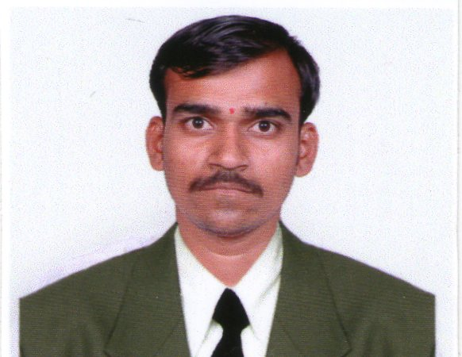
SWAPNIL T. NIKAM

Email Id: swapnilnikam1111@gmail.com
Mobile No. 9689633499

Career Objectives :

Seeking an Electrical Engineer position with a company which will require me to utilize my skills, abilities and experience in the electrical engineering field to ensure the company’s success.

Academic Details:

Examination | Institution | University | Month & Year of passing | Percentage
B.E.Electrical | S.I.T, Lonavala. | Pune | May-2014 | 66.53%
Diploma in Electrical Engineering | R.S.I.E.T.Pedhambe,  Chiplun. | M.S.B.T.E. | May-2011 | 83%
S.S.C. | Narveer Tanaji Malusare Vidyalaya,Devale.Raigad | Mumbai | March-2008 | 77.84%

Experience:
- Project : 1
- Company : SHREE TATYASAHEB KORE WARANA SAHAKARI NAVSHAKTI NIRMAN
SANSTHA LTD. WARANANAGAR.
- Location : KUMBHI HYDRO ELECTRIC PROJECT , GAGANBAWADA. KOLHAPUR
- Duration : 13th NOV 2014 to 21 MAY 2017.
- Post : Site Engineer.
.
Roles And Responsibilities :
- Handling full project.
- Development & Maintenance of hydro project.
- Maintenance of 33 KV SF₆ C.B. & 6.3 KV Vacuum C.B.Power transformer(3150 KVA), Auxiliary transformer(160 KVA), Control Panel, Motor, Diesel Generator, Governor, Lubrication System-Motor, Control Panel, Sensor, Filters, Battery System etc.
- Maintenance of Switch Yard CT, PT, Isolator, Earthing System.
- Handling of equipment- Megger, Multimeter, Tong Tester, Test Lamp.
- To control Plant operations & Process through PLC-SCADA System.
- Planning & Monitoring of scheduled activates.
- Complete all records (documentation).

- Project : 2
- Company : G.B.S. ASSOCIATES. ( Siemens contract )
- Project : Siemens Ltd. Mumbai.
- Location : Mumbai International Airport Ltd. Terminal-2 .
- Duration : 1 August 2017 To 1 Jun 2019.
- Post : Supervisor.

Training Undertaken :

- Industrial Training: In training from 16/05/2010 to 18/06/2010 in Mahatma Phule
Magaswargiya Sahakari Soot Girni Ltd.,Peth Vadgaon,Kolhapur.
- Industrial Training: In training from 22/06/2013 to 28/06/2013 in ELCOM INTERNATIONAL
PVT.LTD.,Gandhinagar,Kolhapur.
- 15th day training in WARANA Sugar factory.

Project:

- Diploma Final Year Project: We successfully completed a project based on topic
“HYBRID POWER SYSTEM” with a group of 4 members.
- BE Final Year Project: We successfully completed a project based on topic
“ISLANDING OF POWER SYSTEM” with a group of 4 members.

Extra-curricular Activities:

- An industrial Visit To Automatic Electrical’s,Lonavala
- An industrial visit to Traction station ,Kalyan
- Participated and Co-ordinated XENOS event in 2012-2013.
- Active Participation of Extracurricular Activities and Games in College.
- The Seminar on “FUEL CELL” & “ISLANDING OF POWER SYSTEMS ”.
- Participated in NSS Camp.
- Runner up in State Level Project Competition “MUTATION 2014”.
- Secured 1st Rank in 10th class of School & Diploma Final Year .

Extra Knowledge:

- Basic knowledge of computer.
- Basic Knowledge of MATLAB, PLC, C Language .

Strength :

- Fast learning and initiative with problem-solving skills.
- Positive attitude.
- Punctuality.
- Adaptable to Changes.

Personal Details:

- Date of Birth : 05th Apr 1993.
- Gender : Male
- Address : At Post- Chavare, Tal- Hatkangale.
Dist. Kolhapur 416 112 (Maharashtra).
- Language known : English, Marathi & Hindi.
- Hobbies: : Reading book, travelling, playing cricket, listening songs.

Declaration:

- I hereby declare that all information are given above is best and true in my knowledge.
Date:
Place:

SWAPNIL T. NIKAM

(Signature)

